Program 1:

package java_tutorial;

import java.util.*;
import org.apache.commons.lang3.ArrayUtils;
import org.apache.commons.lang3.StringUtils;

public class java_tuts {

public static void main(String[] args) {

// 1. Declare arrays
int a[];
a = new int[40];

String[] aArray = new String[5];
String[] bArray = {"a","b","c","d","e"};
String[] cArray = new String[]{"a","b","c","d","e"};

// 2. Print array using Arrays.toString()
int[] intArray = {1,2,3,4,5};
System.out.println(Arrays.toString(intArray));

// 3. Check if array contains a value
String[] stringArray = {"abc","bcd","cba","dcb","efg"};
System.out.println(Arrays.asList(stringArray).contains("abc"));

// 4. Concatenate two arrays
int[] intArray2 = {6,7,8,9,10};
int[] mergedArray = ArrayUtils.addAll(intArray, intArray2);
System.out.println(Arrays.toString(mergedArray));

// 6. Join elements of array into a single string
String joined = StringUtils.join(new String[]{"a","b","c"}, ", ");
System.out.println(joined);

// 8. Convert array to set
String[] s1 = {"a","b","c","d","e","a"};
Set<String> set = new HashSet<>(Arrays.asList(s1));
System.out.println(set);

// 9. Reverse an array
int[] reverseArray = {1,2,3,4,5};
ArrayUtils.reverse(reverseArray);
System.out.println(Arrays.toString(reverseArray));

// 10. Remove an element from array
int[] removed = ArrayUtils.removeElement(intArray, 3);
System.out.println(Arrays.toString(removed));
}
}

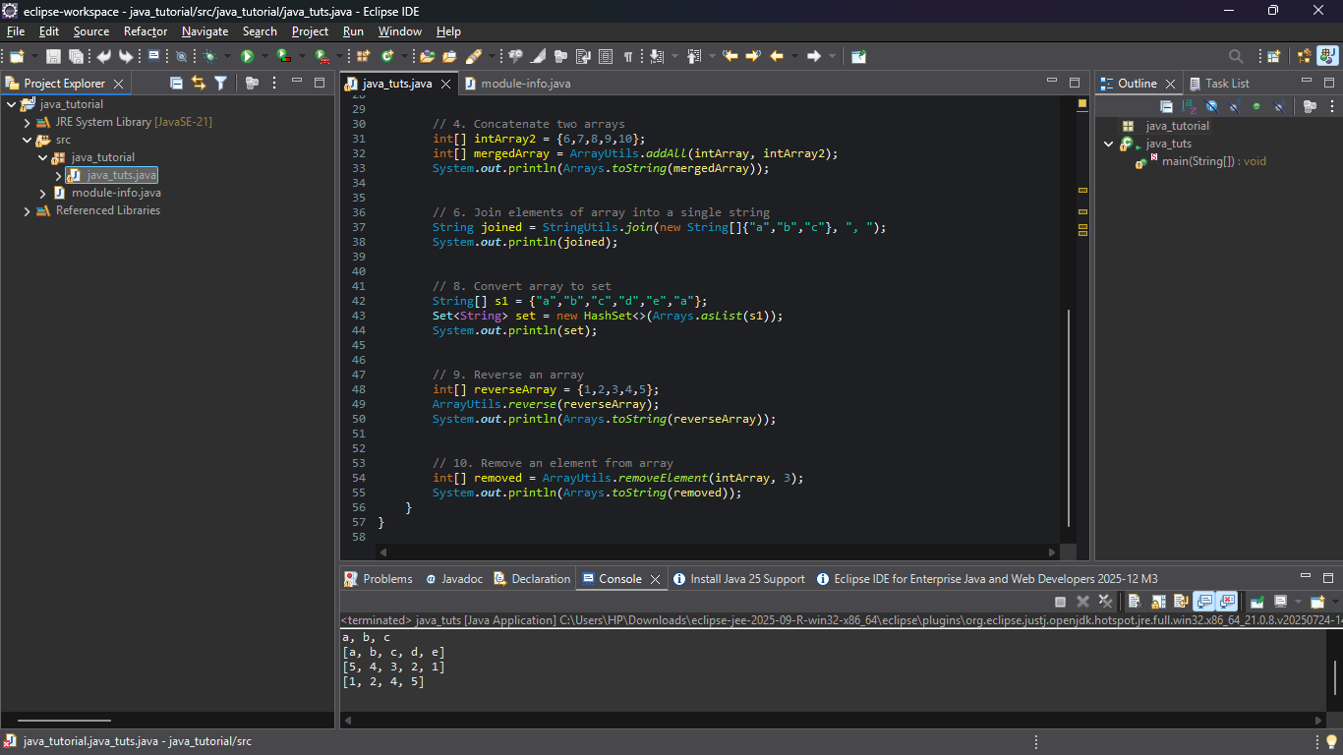

Program 2:

package java_tutorial;

public class java_tuts {
public static void main(String[] args) {
String s = "sathyabama";
StringBuffer s1 = new StringBuffer("sathyabama");
StringBuilder s2 = new StringBuilder("sathyabama");
s.concat(" College");
s1.append(" College");
s2.append(" College");

System.out.println(s);
System.out.println(s1);
System.out.println(s2);
}
}
